Assignment 1

#Laboratory Exercise 3, Assignment 1

.data # DECLARE VARIABLES

i : .word 5

j : .word -1

.text

la $t8, i # Get the address of X in Data Segment

la $t9, j # Get the address of Y in Data Segment

lw $s1, 0($t8) # $t1 = i

lw $s2, 0($t9) # $t2 = j

start:

slt $t0,$s2,$s1 # i>j

bne $t0,$zero,else # branch to else if j<i

addi $t1,$t1,1 #then part: x=x+1

addi $t3,$zero,1 # z=1

j endif # skip “else” part

else:

addi $t2,$t2,-1 # begin else part: y=y-1

add $t3,$t3,$t3 # z=2*z

endif:

* Trường hợp i=5, j=-1:

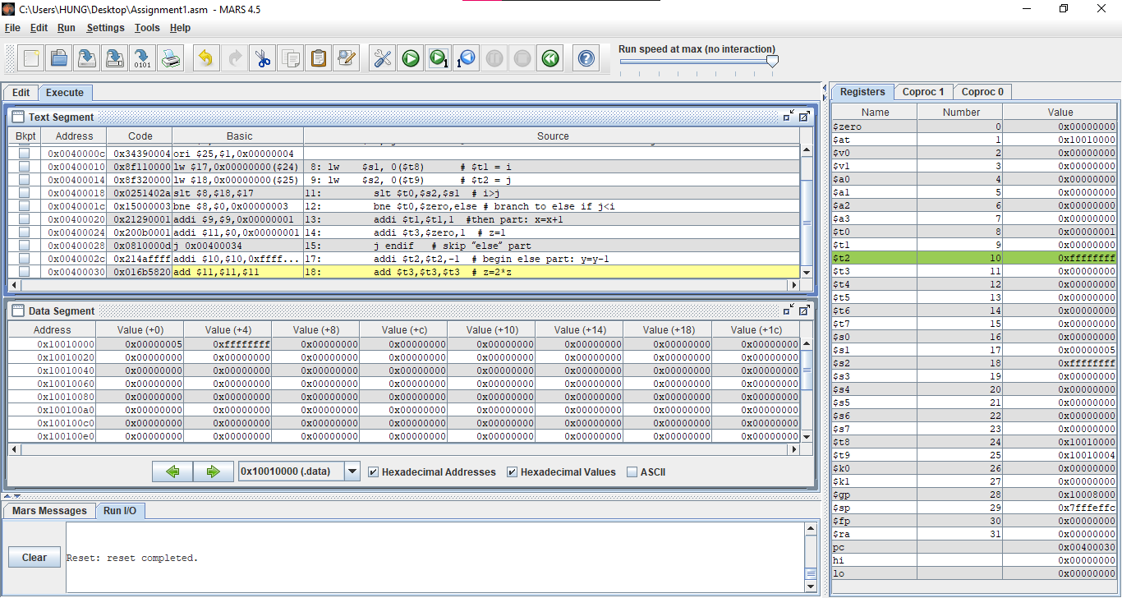

* + Chương trình sẽ rẽ nhánh đến:

addi $t2,$t2,-1 # begin else part: y=y-1

add $t3,$t3,$t3 # z=2*z

* + y=$t2=-1; z=$t3=0
* Trường hợp i=1, j=2:

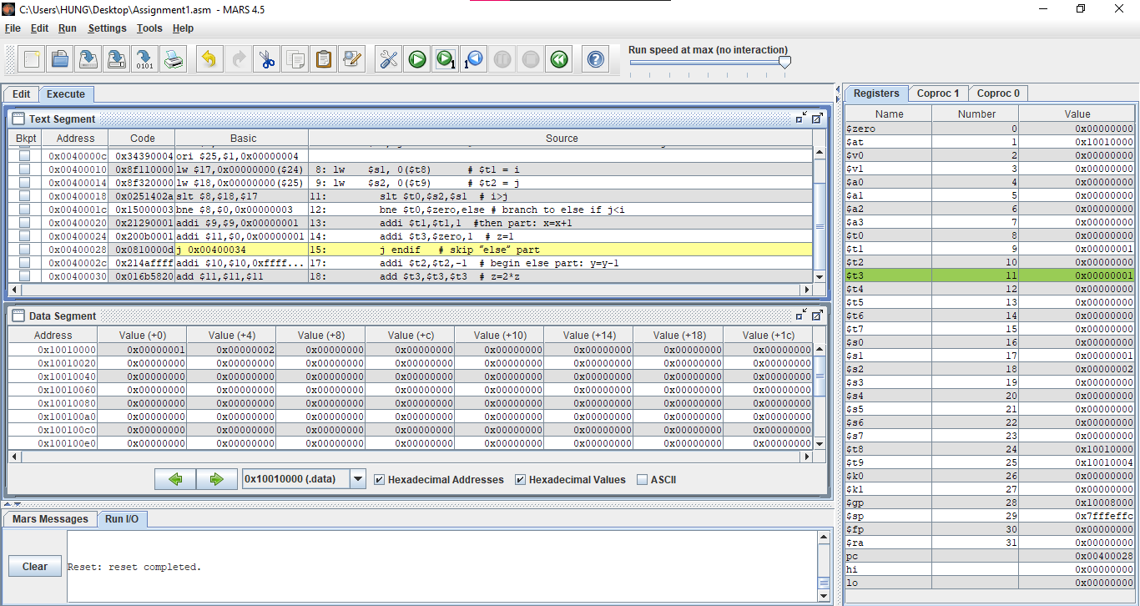

* + Chương trình sẽ rẽ nhánh đến:

addi $t1,$t1,1 #then part: x=x+1

addi $t3,$zero,1 # z=1 y=$t2=-1; z=$t3=0

* + x=$t1=1; z=$t3=1

Assignment 2

#Laboratory Exercise 3, Assigment 2

.data # DECLARE VARIABLES

A: .word 10, 20, 30, 40, 50

.text

la $s2, A #s2: dia chi mang A

addi $s5, $zero, 0 # sum = 0

addi $s1, $zero, 0 # i = 0

addi $s3, $zero, 5 # n =

addi $s4, $zero, 1 # step =

loop:

slt $t2, $s1, $s3 # $t2 = i < n ? 1 : 0

beq $t2, $zero, endloop

add $t1, $s1, $s1 # $t1 = 2 * $s1

add $t1, $t1, $t1 # $t1 = 4 * $s1

add $t1, $t1, $s2 # $t1 store the address of A[i]

lw $t0, 0($t1) # load value of A[i] in $t0

add $s5, $s5, $t0 # sum = sum + A[i]

add $s1, $s1, $s4 # i = i + step

j loop # goto loop

endloop:

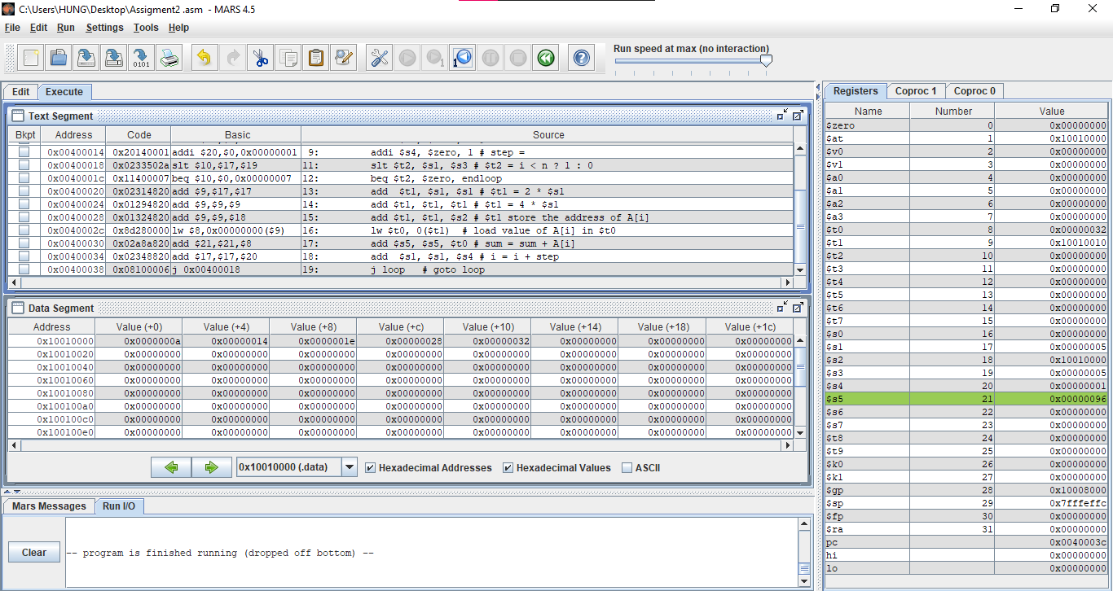

* Thực hiện chương trình với:
  + A=[10, 20, 30, 40, 50]
  + n=5
  + step=1
* Vòng lặp lặp lại 5 lần với i=0, 1, 2, 3, 4. Đến i=5 thì nhảy đến endloop và vòng lặp kết thúc
* Sau khi kết thúc vòng lặp thì sum=$s5=(96)16 = (150)10

Assignment 3

#Laboratory Exercise 3, Assignment 3

.data

test: .word 0

.text

la $s0, test #load the address of test variable

lw $s1, 0($s0) #load the value of test to register $t1

li $t0, 0 #load value for test case

li $t1, 1

li $t2, 2

beq $s1, $t0, case_0

beq $s1, $t1, case_1

beq $s1, $t2, case_2

j default

case_0:

addi $s2, $s2, 1 #a=a+1

j continue

case_1:

sub $s2, $s2, $t1 #a=a-1

j continue

case_2:

add $s3, $s3, $s3 #b=2*b

j continue

default:

continue:

* Trường hợp test=0, chương trình nhảy đến case_0: a=a+1=$s2+1=1

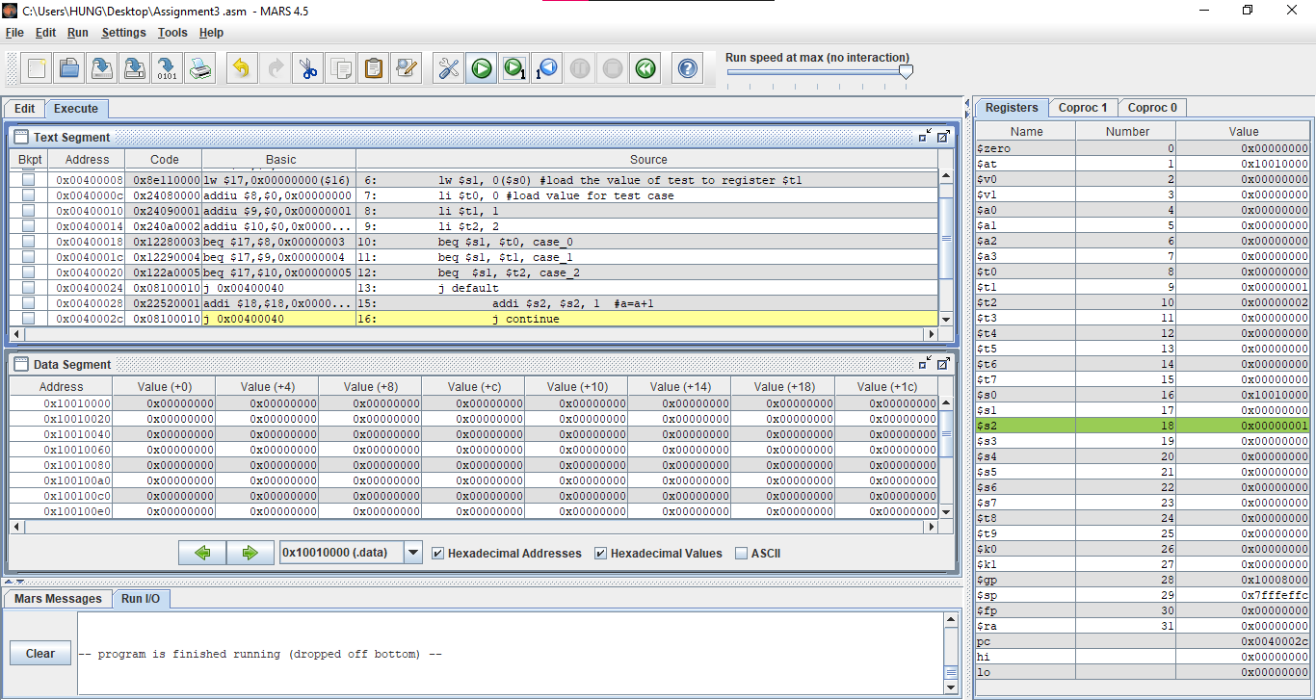

* Trường hợp test=1, chương trình nhảy đến case_1: a=a-1=$s2-1=-1

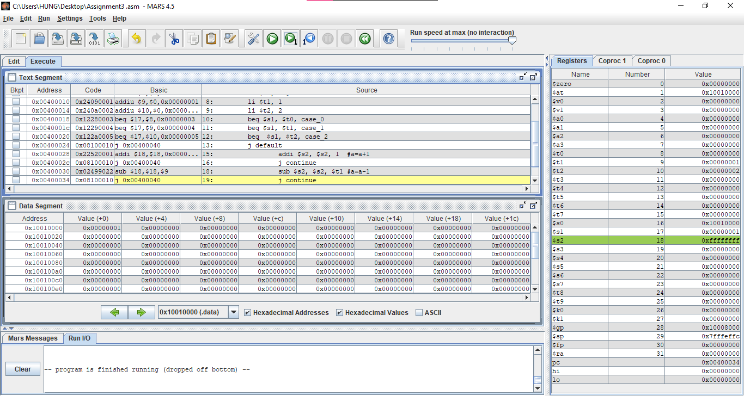

* Trường hợp test=2, chương trình nhảy đến case_2: b=2*b=b+b= $s3+ $s3= 0+0=0

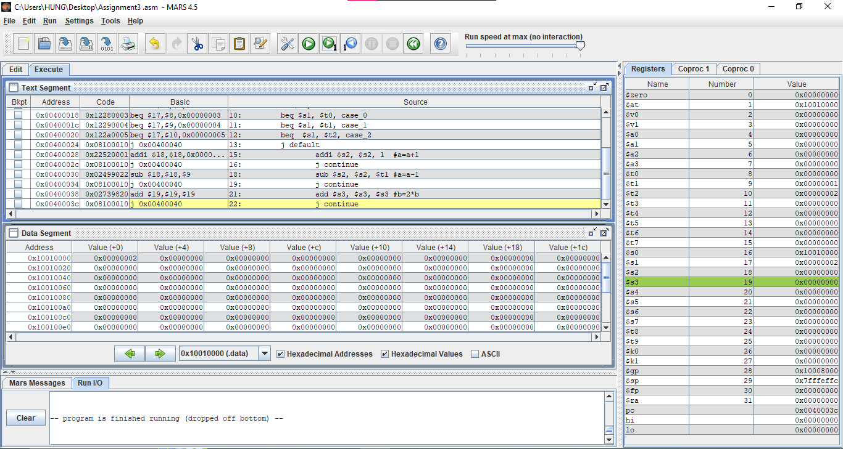

Assignment 4

a)

#Laboratory Exercise 3, Assignment 4a

.data # DECLARE VARIABLES

i : .word 1

j : .word 2

.text

la $t8, i # Get the address of X in Data Segment

la $t9, j # Get the address of Y in Data Segment

lw $s1, 0($t8) # $t1 = i

lw $s2, 0($t9) # $t2 = j

start:

slt $t0,$s1,$s2 # i<j

bne $t0,$zero,else # branch to else

addi $t1,$t1,1 #then part: x=x+1

addi $t3,$zero,1 # z=1

j endif # skip “else” part

else:

addi $t2,$t2,-1 # begin else part: y=y-1

add $t3,$t3,$t3 # z=2*z

endif:

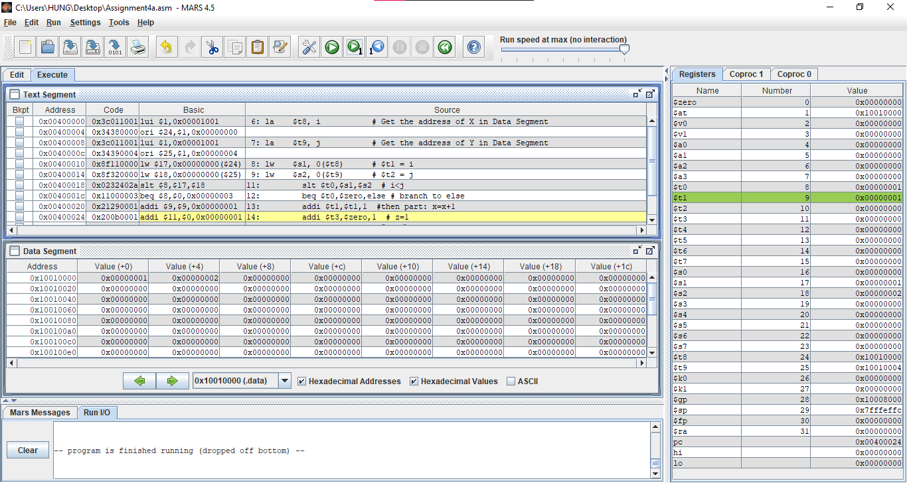

* Thay đổi điều kiện thành i<j, ta có dòng lệnh: slt $t0,$s1,$s2 # i<j
* beq $t0,$zero,else: nếu i>=j thì $t0=0, nhảy đến else:
* Trường hợp còn lại bỏ qua nhánh else:

b)

#Laboratory Exercise 3, Assignment 4a

.data # DECLARE VARIABLES

i : .word 3

j : .word 2

.text

la $t8, i # Get the address of X in Data Segment

la $t9, j # Get the address of Y in Data Segment

lw $s1, 0($t8) # $t1 = i

lw $s2, 0($t9) # $t2 = j

start:

slt $t0,$s1,$s2 # i<j

bne $t0,$zero,else # branch to else

addi $t1,$t1,1 #then part: x=x+1

addi $t3,$zero,1 # z=1

j endif # skip “else” part

else:

addi $t2,$t2,-1 # begin else part: y=y-1

add $t3,$t3,$t3 # z=2*z

endif:

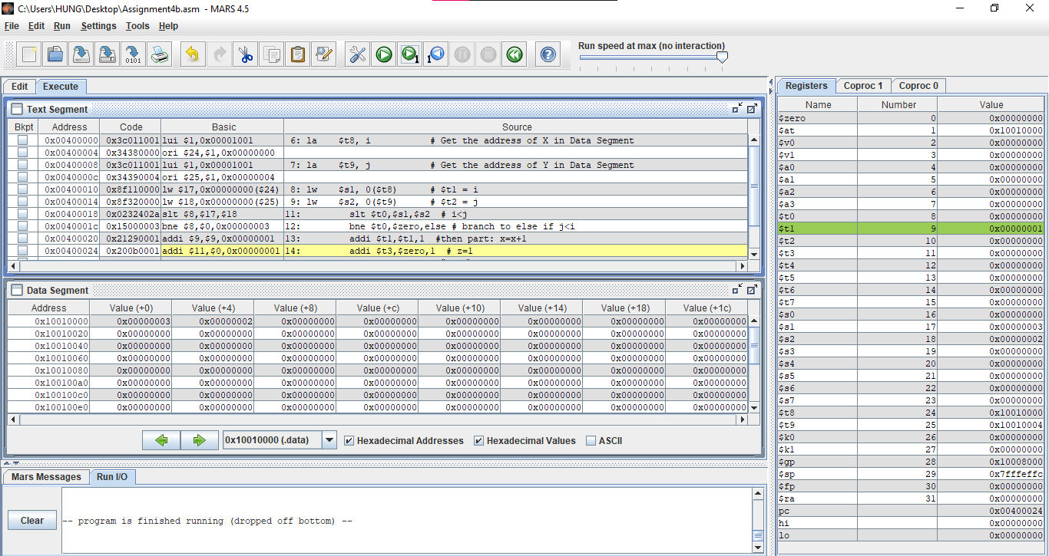

* Thay đổi điều kiện thành i>=j, ta có dòng lệnh: slt $t0,$s1,$s2 # i<j
* bne $t0,$zero,else: nếu i>=j thì $t0=0, thực hiện bình thường rồi bỏ qua nhánh else
* Trường hợp còn lại nhảy đến nhánh else:

c)

#Laboratory Exercise 3, Assignment 4c

.data # DECLARE VARIABLES

i : .word -1

j : .word -1

.text

la $t8, i # Get the address of X in Data Segment

la $t9, j # Get the address of Y in Data Segment

lw $s1, 0($t8) # $t1 = i

lw $s2, 0($t9) # $t2 = j

add $s1,$s1,$s2 # $s1 = i+j

start:

slt $t0,$zero,$s1 # 0<i+j

bne $t0,$zero,else # branch to else

addi $t1,$t1,1 #then part: x=x+1

addi $t3,$zero,1 # z=1

j endif # skip “else” part

else:

addi $t2,$t2,-1 # begin else part: y=y-1

add $t3,$t3,$t3 # z=2*z

endif:

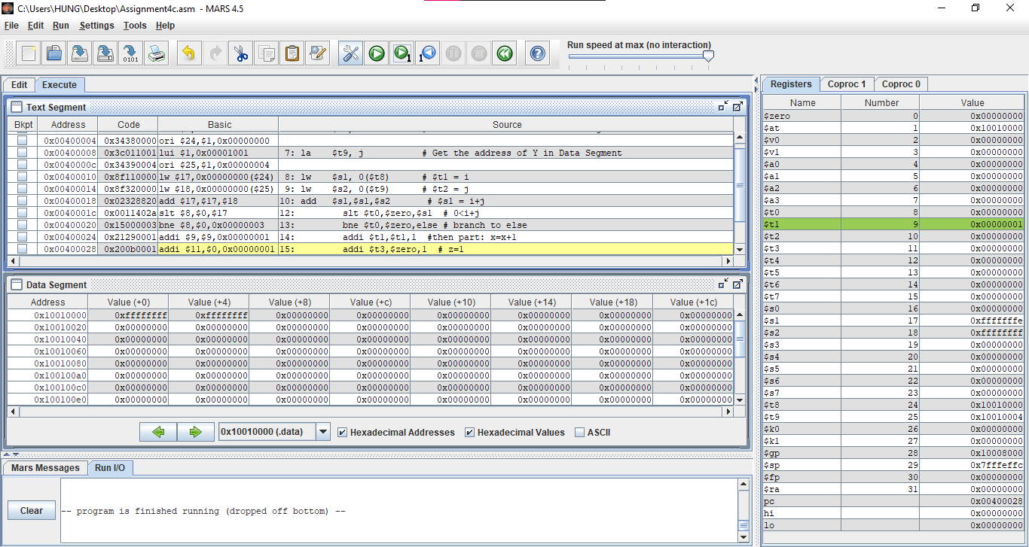

* Thay đổi điều kiện thành i+j <= 0, ta có dòng lệnh: slt $t0,$zero,$s1 # 0<i+j
* bne $t0,$zero,else # branch to else: nếu i+j>0 thì $t0=1, nhảy đến else:
* Trường hợp còn lại bỏ qua nhánh else:

d)

#Laboratory Exercise 3, Assignment 4d

.data # DECLARE VARIABLES

i : .word -1

j : .word -1

.text

la $t8, i # Get the address of X in Data Segment

la $t9, j # Get the address of Y in Data Segment

lw $s1, 0($t8) # $t1 = i

lw $s2, 0($t9) # $t2 = j

add $s1,$s1,$s2 # $s1 = i+j

add $s6,$s6,0 # $s6 = m

add $s7,$s7,0 # $s7 = n

add $s6,$s6,$s7 # $s6 = m+n

start:

slt $t0,$s6,$s1 # m+n<i+j

beq $t0,$zero,else # branch to else

addi $t1,$t1,1 #then part: x=x+1

addi $t3,$zero,1 # z=1

j endif # skip “else” part

else:

addi $t2,$t2,-1 # begin else part: y=y-1

add $t3,$t3,$t3 # z=2*z

endif:

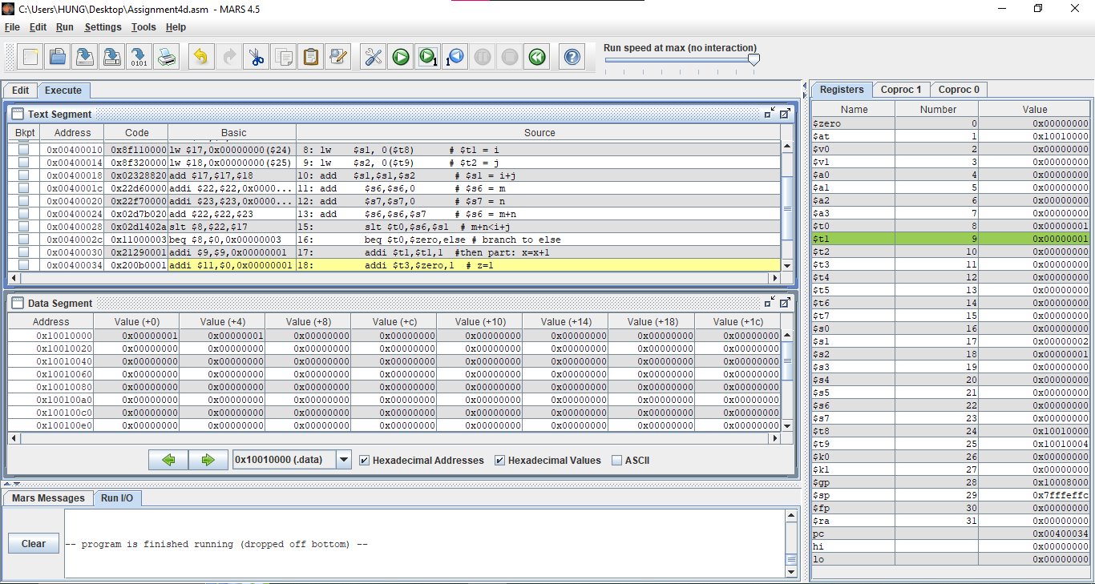

Assignment 5

a)

#Laboratory Exercise 3, Assigment 5a

.data # DECLARE VARIABLES

A: .word 10, 20, 30, 40, 50

.text

la $s2, A #s2: dia chi mang A

addi $s5, $zero, 0 # sum = 0

addi $s1, $zero, 0 # i = 0

addi $s3, $zero, 5 # n =

addi $s4, $zero, 1 # step =

loop:

slt $t2, $s1, $s3 # $t2 = i < n ? 1 : 0

bne $t2, $zero, endloop

add $t1, $s1, $s1 # $t1 = 2 * $s1

add $t1, $t1, $t1 # $t1 = 4 * $s1

add $t1, $t1, $s2 # $t1 store the address of A[i]

lw $t0, 0($t1) # load value of A[i] in $t0

add $s5, $s5, $t0 # sum = sum + A[i]

add $s1, $s1, $s4 # i = i + step

j loop # goto loop

endloop:

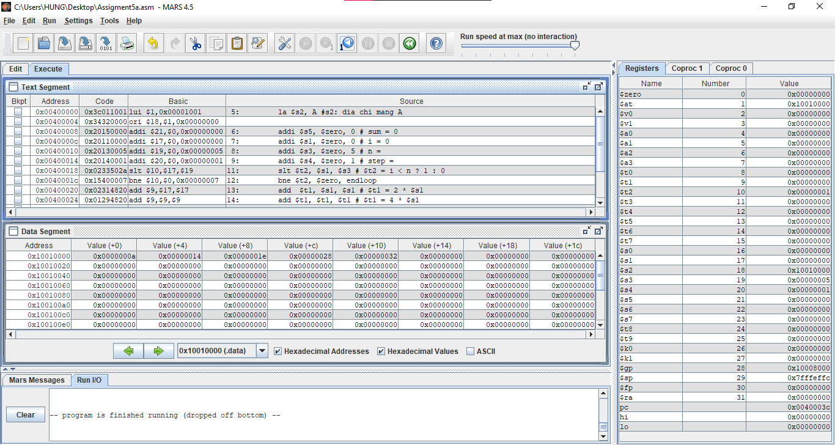

b)

#Laboratory Exercise 3, Assigment 5b

.data # DECLARE VARIABLES

A: .word 10, 20, 30, 40, 50

.text

la $s2, A #s2: dia chi mang A

addi $s5, $zero, 0 # sum = 0

addi $s1, $zero, 0 # i = 0

addi $s3, $zero, 5 # n =

addi $s4, $zero, 1 # step =

loop:

slt $t2, $s3, $s1 # $t2 = n < i ? 1 : 0

beq $t2, $zero, endloop

add $t1, $s1, $s1 # $t1 = 2 * $s1

add $t1, $t1, $t1 # $t1 = 4 * $s1

add $t1, $t1, $s2 # $t1 store the address of A[i]

lw $t0, 0($t1) # load value of A[i] in $t0

add $s5, $s5, $t0 # sum = sum + A[i]

add $s1, $s1, $s4 # i = i + step

j loop # goto loop

endloop:

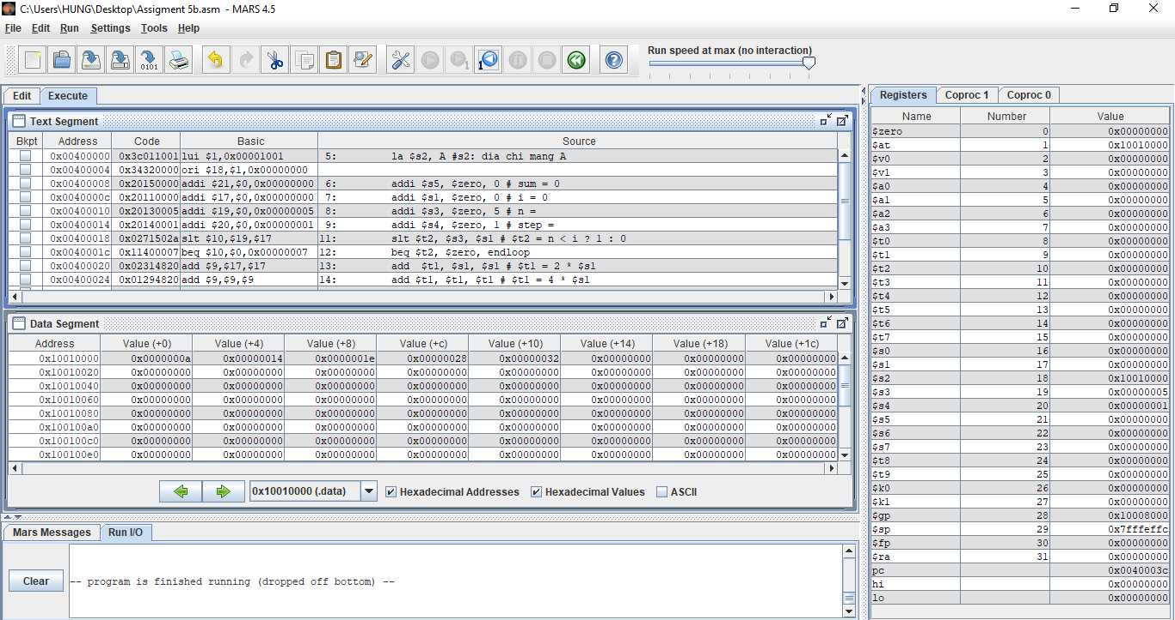

c)

#Laboratory Exercise 3, Assigment 5c

.data # DECLARE VARIABLES

A: .word 10, 20, 30, 40, 50

.text

la $s2, A #s2: dia chi mang A

addi $s5, $zero, 0 # sum = 0

addi $s1, $zero, 0 # i = 0

addi $s3, $zero, 5 # n =

addi $s4, $zero, 1 # step =

loop:

add $t1, $s1, $s1 # $t1 = 2 * $s1

add $t1, $t1, $t1 # $t1 = 4 * $s1

add $t1, $t1, $s2 # $t1 store the address of A[i]

lw $t0, 0($t1) # load value of A[i] in $t0

add $s5, $s5, $t0 # sum = sum + A[i]

slt $t2, $s5, $zero # $s5 = sum < 0 ? 1 : 0

bne $t2, $zero, endloop

add $s1, $s1, $s4 # i = i + step

j loop # goto loop

endloop:

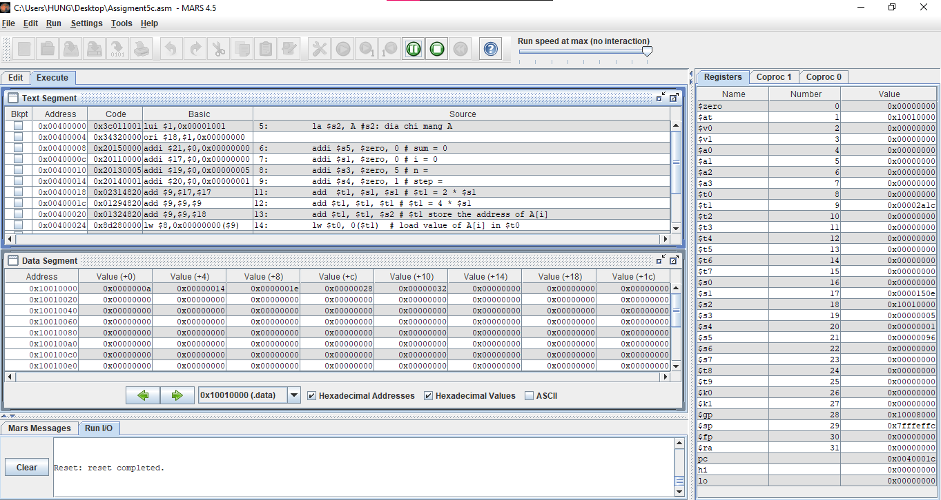

d)

#Laboratory Exercise 3, Assigment 5d

.data # DECLARE VARIABLES

A: .word 10, 20, 30, 40, 50

.text

la $s2, A #s2: dia chi mang A

addi $s5, $zero, 0 # sum = 0

addi $s1, $zero, 0 # i = 0

addi $s3, $zero, 5 # n =

addi $s4, $zero, 1 # step =

loop:

add $t1, $s1, $s1 # $t1 = 2 * $s1

add $t1, $t1, $t1 # $t1 = 4 * $s1

add $t1, $t1, $s2 # $t1 store the address of A[i]

lw $t0, 0($t1) # load value of A[i] in $t0

beq $t0, $zero, endloop

add $s5, $s5, $t0 # sum = sum + A[i]

add $s1, $s1, $s4 # i = i + step

j loop # goto loop

endloop:

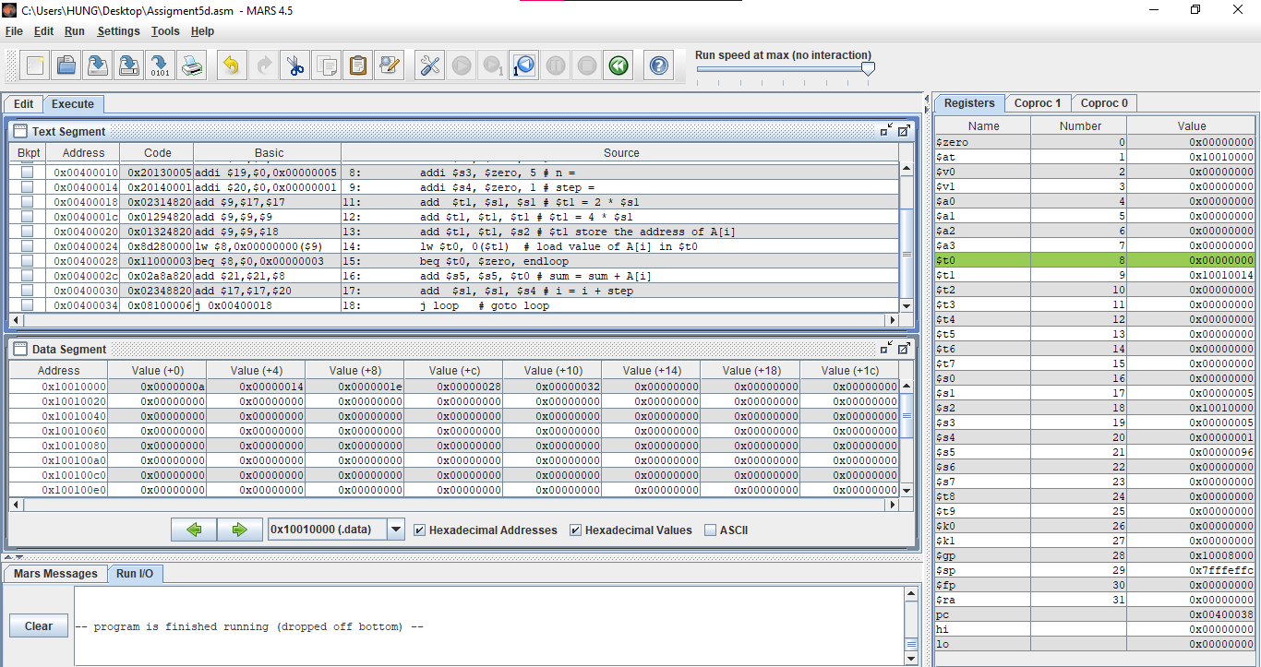

Assignment 6

#Laboratory Exercise 3, Assigment 6

.data # DECLARE VARIABLES

A: .word 10, 20, 30, 50, -50

.text

la $s2, A #s2: dia chi mang A

addi $s5, $zero, 0 # max = 0

addi $s1, $zero, 0 # i = 0

addi $s3, $zero, 5 # n =

addi $s4, $zero, 1 # step =

loop:

slt $t2, $s1, $s3 # $t2 = i < n ? 1 : 0

beq $t2, $zero, endloop

add $t1, $s1, $s1 # $t1 = 2 * $s1

add $t1, $t1, $t1 # $t1 = 4 * $s1

add $t1, $t1, $s2 # $t1 store the address of A[i]

lw $t0, 0($t1) # load value of A[i] in $t0

slt $t2, $t0, $zero

bne $t2, $zero, absolute

j compare

absolute:

sub $t0, $zero, $t0

compare:

slt $t2, $s5, $t0 # if max<A[i]

bne $t2, $zero, swap

j plus

swap:

add $s5, $t0, $zero

plus:

add $s1, $s1, $s4 # i = i + step

j loop # goto loop

endloop: